Application Process

1 Go to Log-in page https://apply.usask.ca/RecruitCE/Account/Login?ReturnUrl=%2frecruitce

*If this is your first time logging in, click on “Create Account” at the top of the page to create a profile.
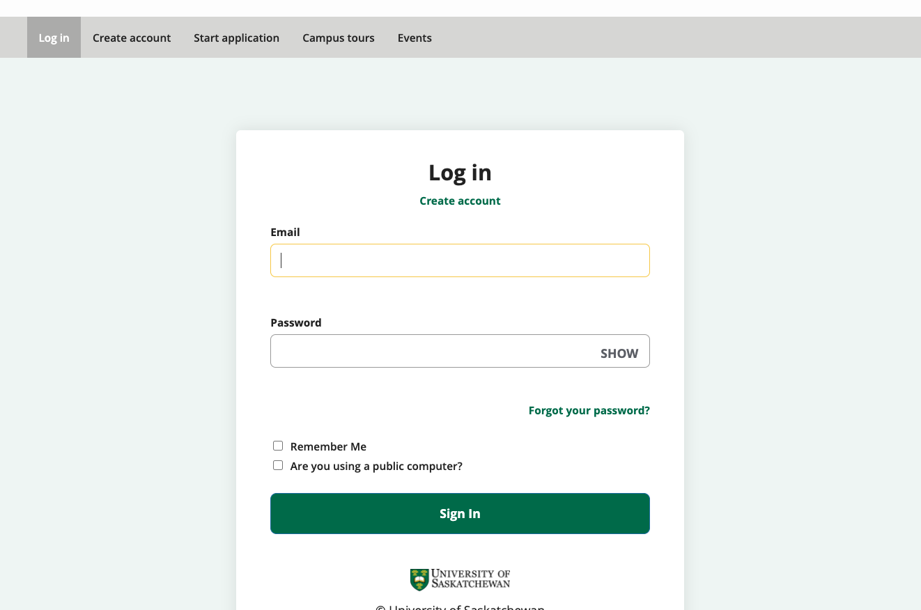

2 Create Account
** All fields with a red star are required fields. If you miss any of these, you will receive and error message.

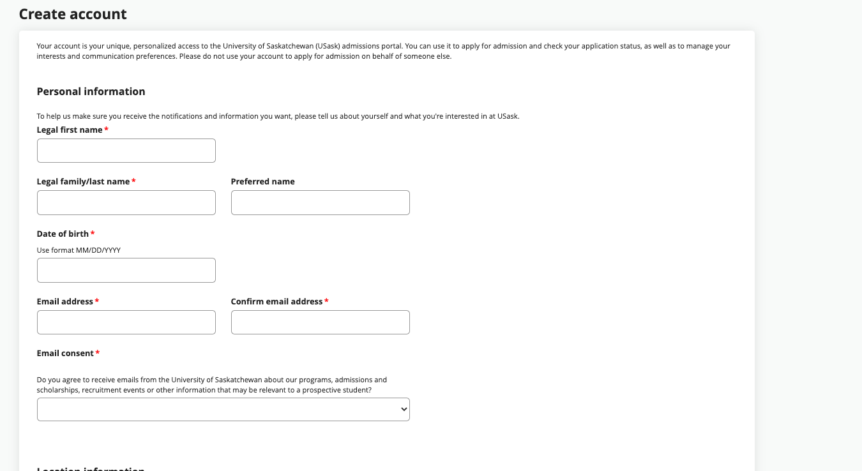
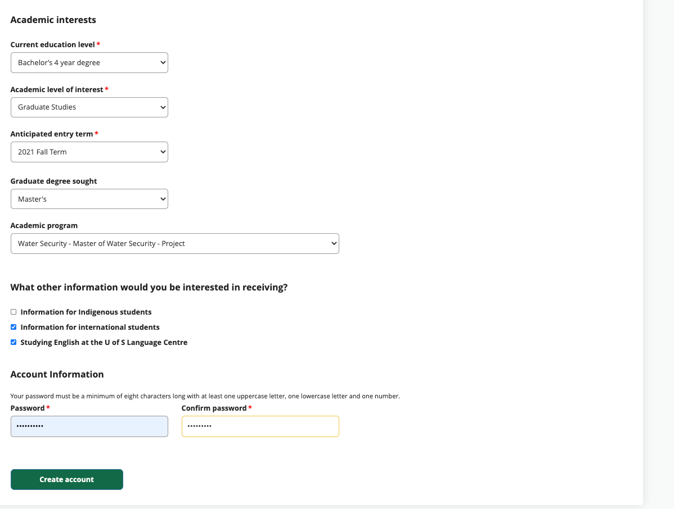

2 Start Application
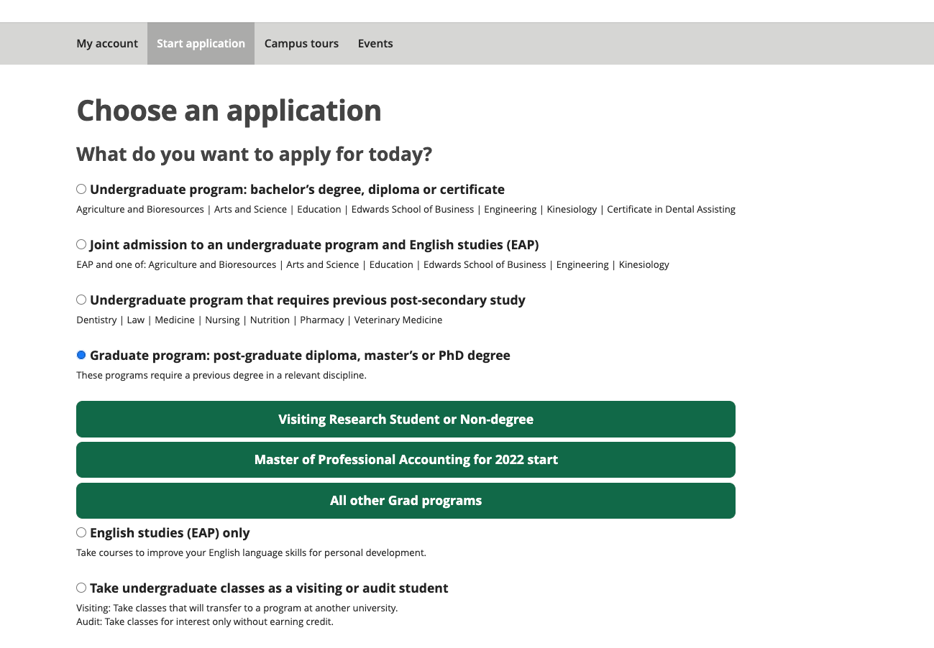
3 Enter all application information
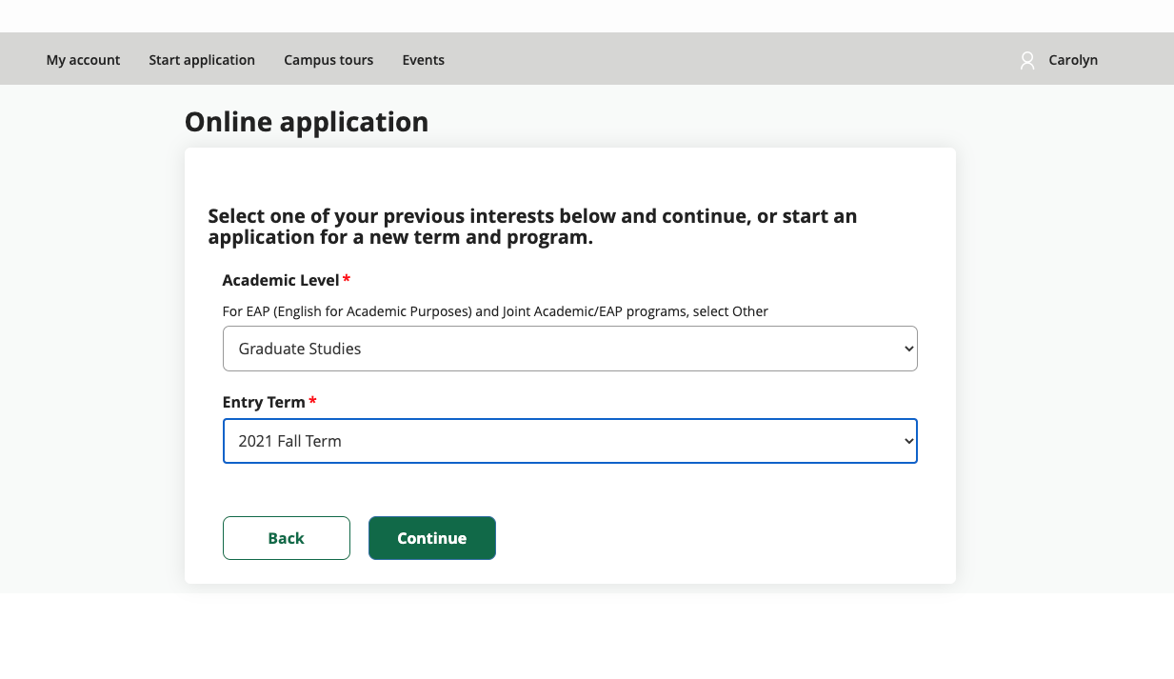
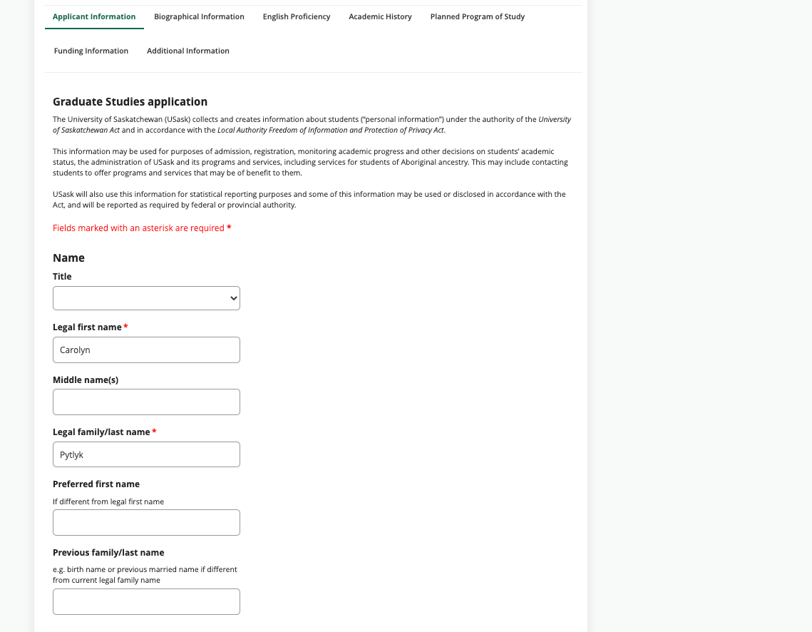
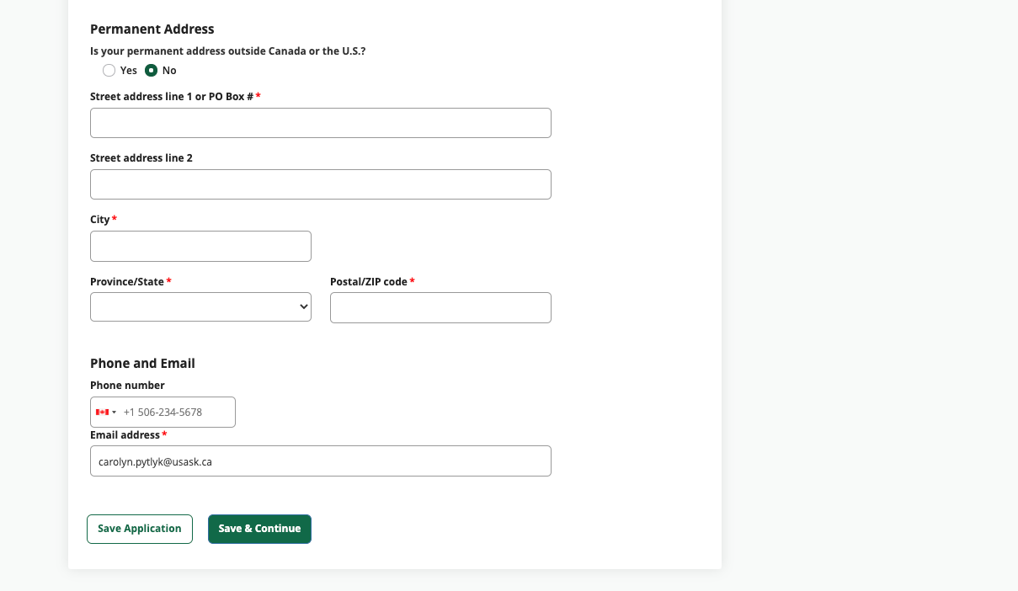
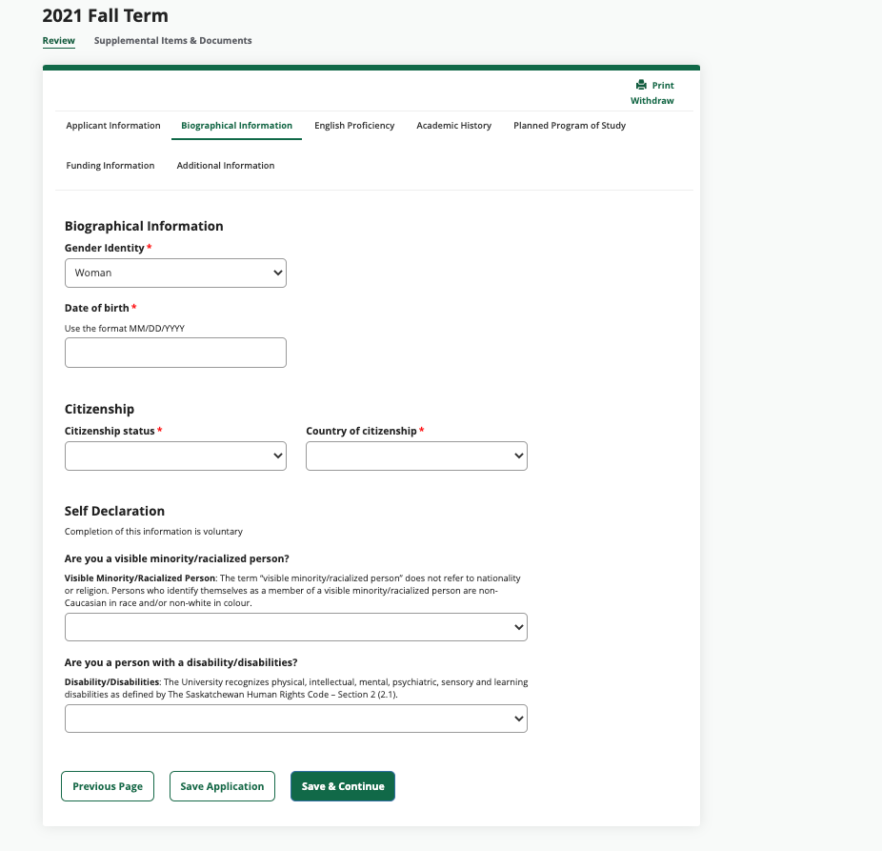
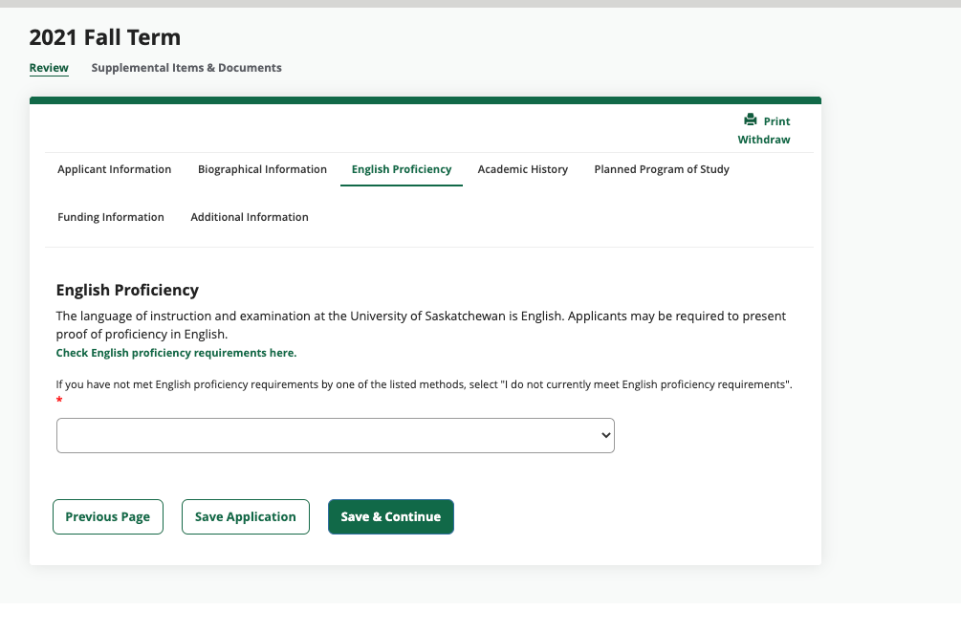

** be sure to enter all your post-secondary information

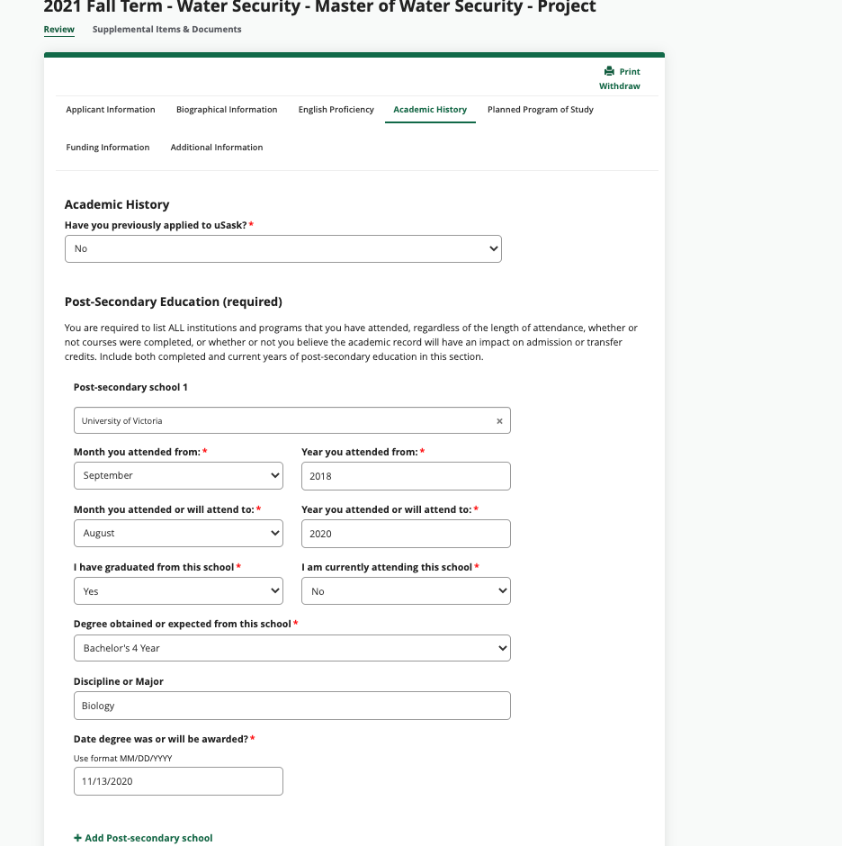
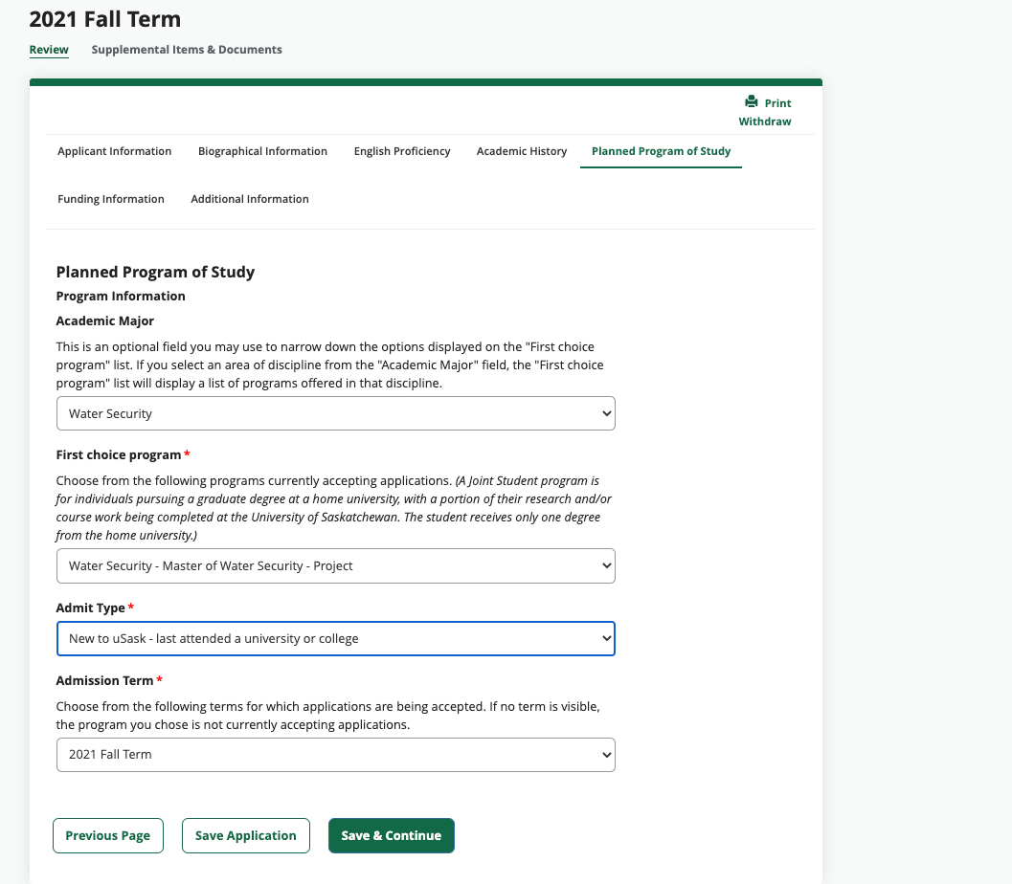
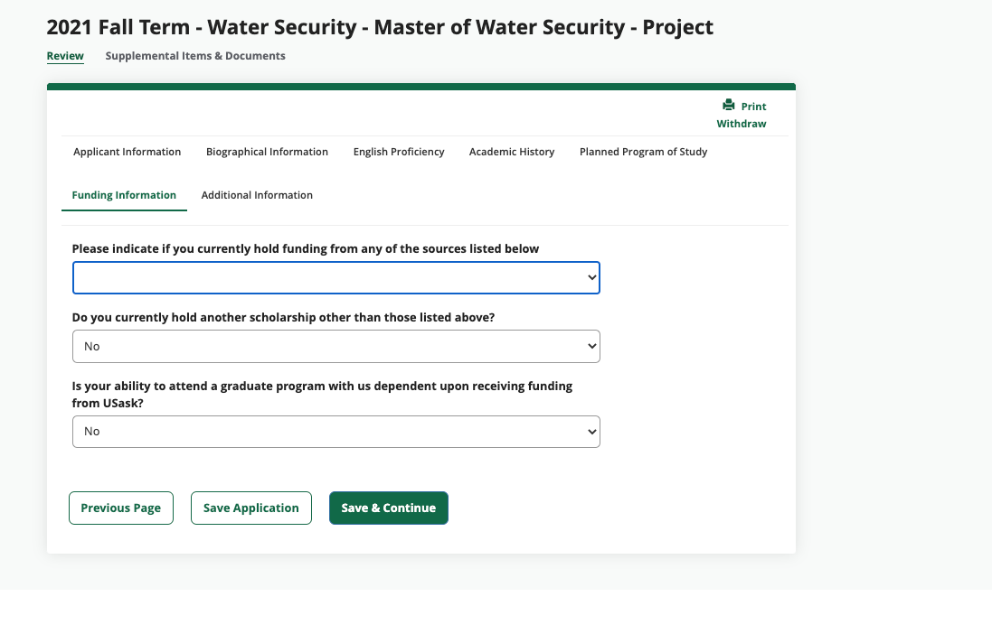
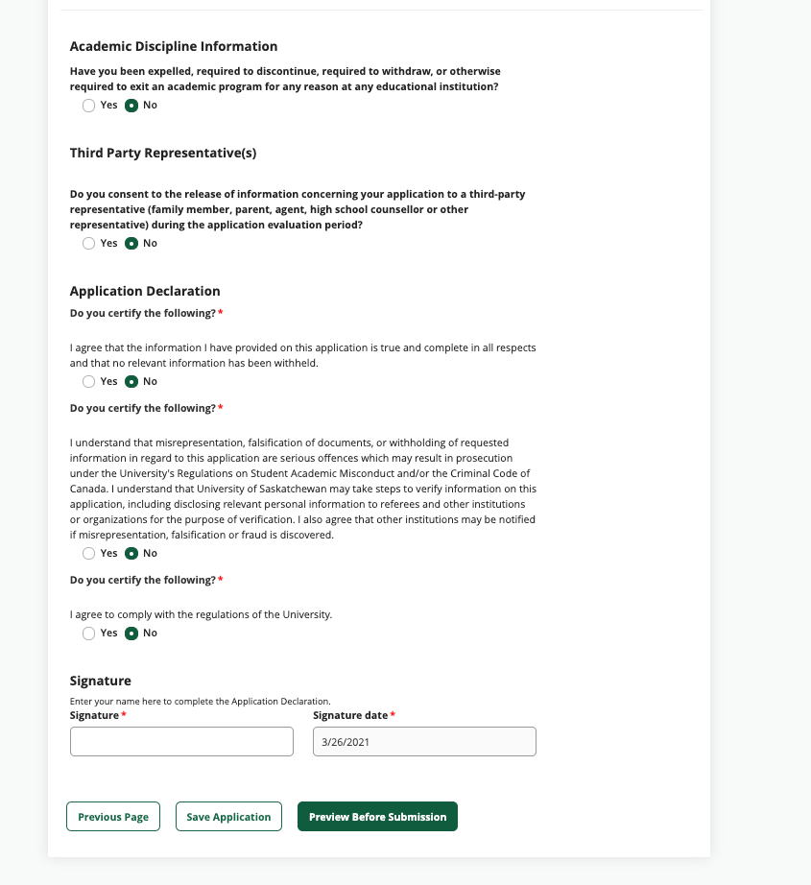

You can add your “signature” by simply typing your name.

6 Preview entire application before submitting

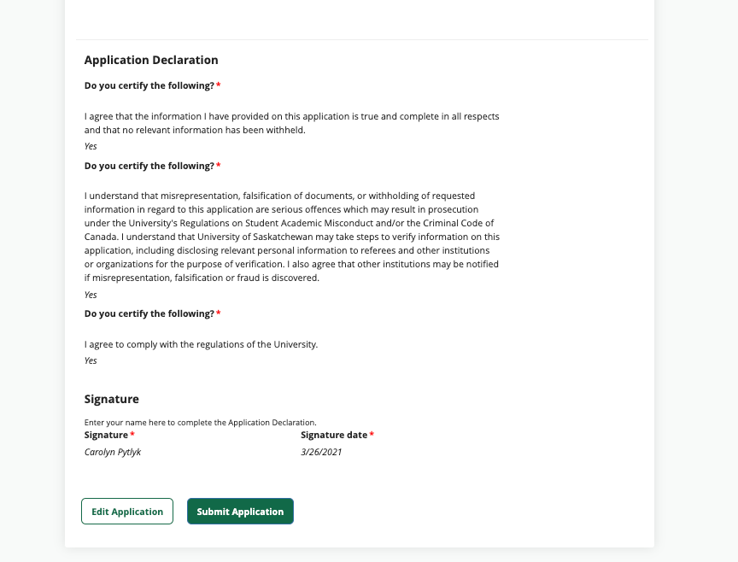

7 Pay application fee

The application fee must be paid before you will be able to upload any documents (e.g., transcripts, degrees).

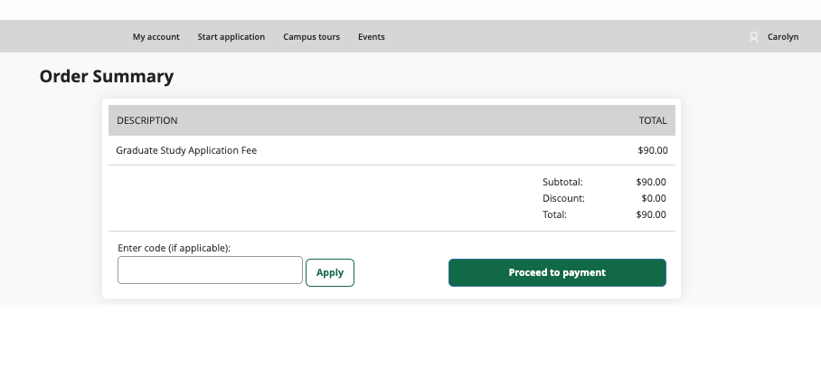

8 View Application and upload all supplemental materials
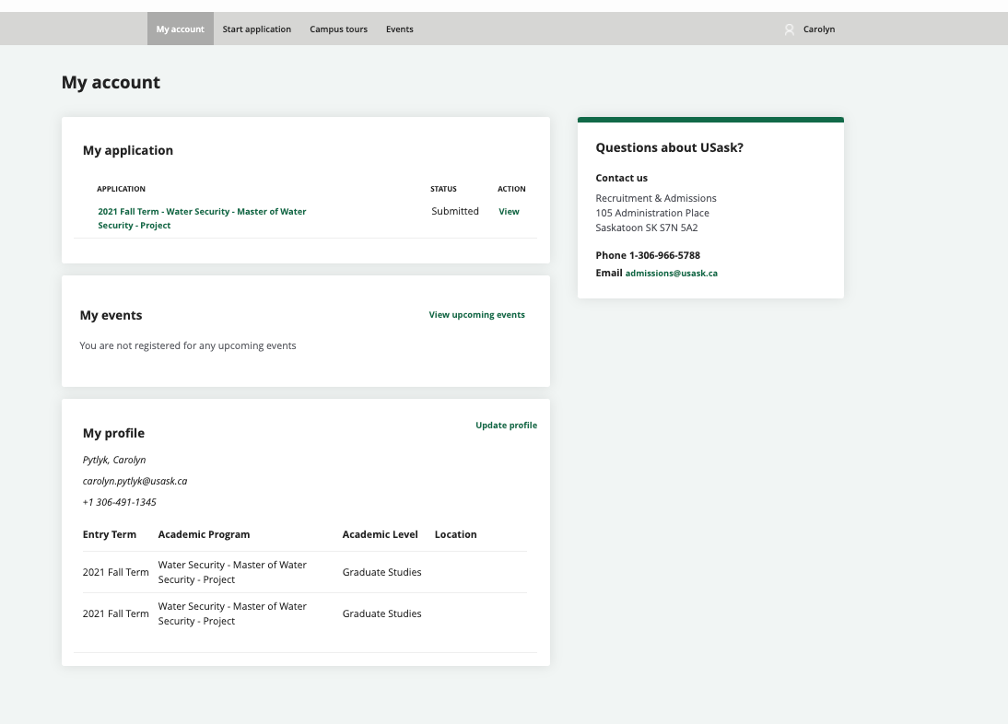
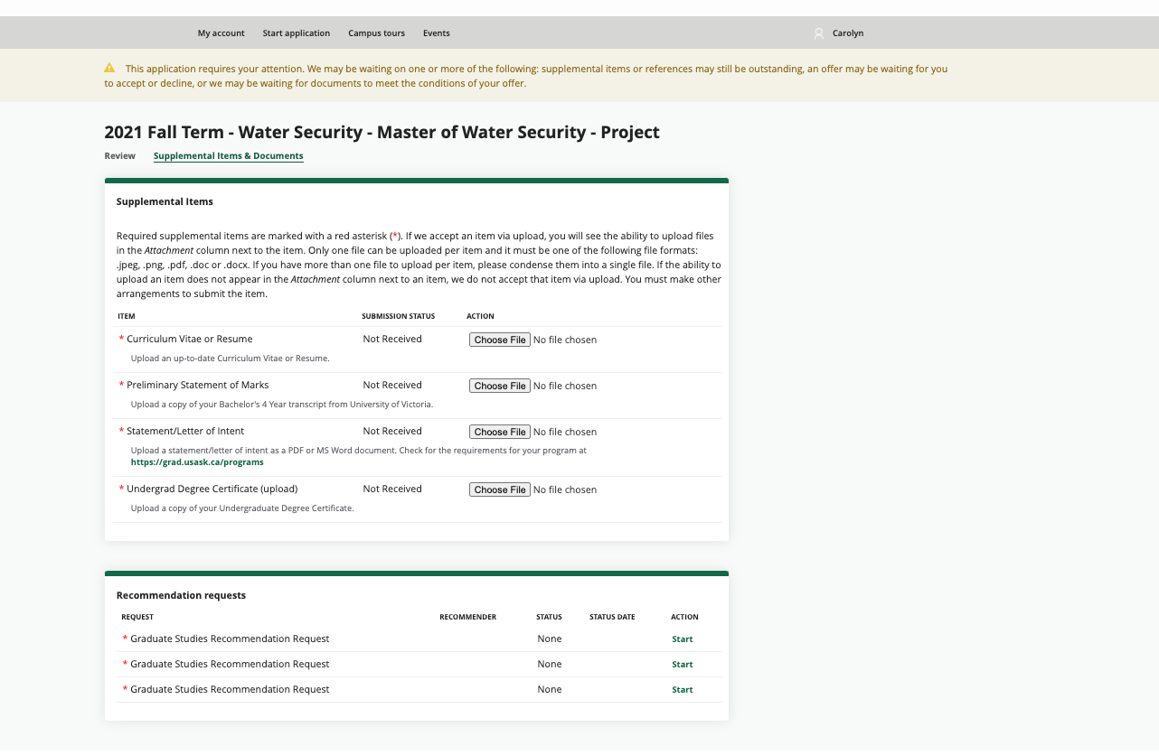

NOTE: The application will not be marked complete until all supplemental materials are uploaded, including letters of recommendation. The people providing those letters of recommendation will do so through the link they receive via an automatic email from the system. Applicants will not be able to upload letters of recommendation themselves.

